NAME:Rishik JK
REG.NO :192511052

CSA1702-ARTIFICIAL INTELLIGENCE
LAB EXPERIMENT

Experiment 7 – Breadth First Search (BFS)

AIM
To write a Python program to implement Breadth First Search (BFS) for traversing a graph.

ALGORITHM
- Start the program.
- Create a graph using nodes and their neighbours.
- Select the starting node.
- Add the starting node to the queue.
- Remove a node from the queue and visit it.
- Add its unvisited neighbours to the queue.
- Repeat until the queue becomes empty.
- Stop the program.

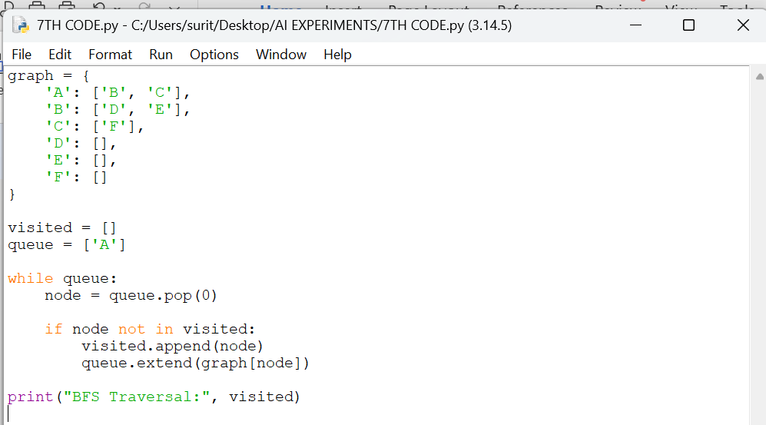

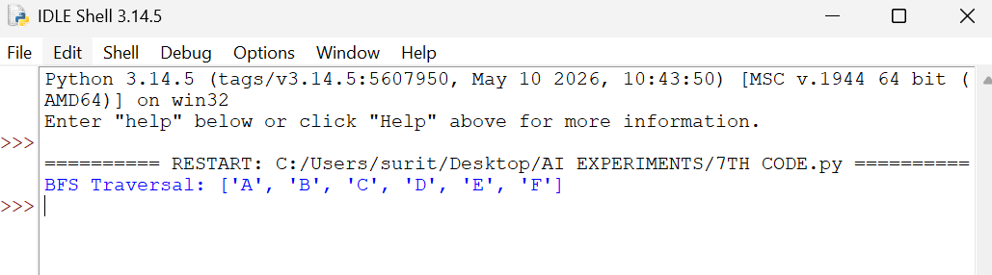

RESULT
Thus, the Breadth First Search algorithm was implemented successfully using Python.

